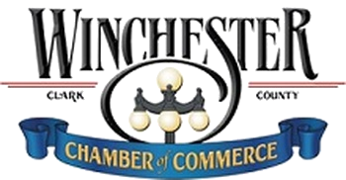
Past winners in their respective categories:

CITIZEN OF THE YEAR

Mary McCammish Davis ’05
Fara Fox Tyree ‘06
Elizabeth Chalfant ‘07
Centerline ‘08
Lee Cruse ‘09
S. Dudley Taylor ‘10
Ed Mastrean ‘11
Ron Tierney ‘12
Cindy Powe-Juett ‘13
Roy Turley ‘14
Debbie Barnes ‘15

COMMUNITY SERVICE AWARD
(FORMERLY VOLUNTEER OF THE YEAR)

Dr. Scott & Stacy Baker ‘05
Sarah S. Glenn ‘06
Flora Shelby ‘07
Gina Lang ‘08
Randy Ballard ‘09
Terry Davidson ‘10
Tammy Moberly ‘11
Jenny Bailey ‘12
David Hoffman ‘13
Brett Cheuvront ‘14
Ron Kibbey ‘15

BUSINESS / INDUSTRY OF THE YEAR

Central Bank ’05
Rose Mary C. Brooks Place ‘06
Buggies Unlimited ’07
Winchester Farms Dairy ‘08
Community Alternatives ‘09
Doyle’s Lawn & Landscaping ‘10
Clark Regional Medical Center ‘11
Stuff Recycling ‘12
J & T Distributing ‘13
Catalent ‘14
Infiltrator Systems, Inc ‘15

COMMUNITY PARTNER OF THE YEAR

Craig’s Auto Repair ‘15

NON-PROFIT OF THE YEAR

Clark County Community Service ‘15

