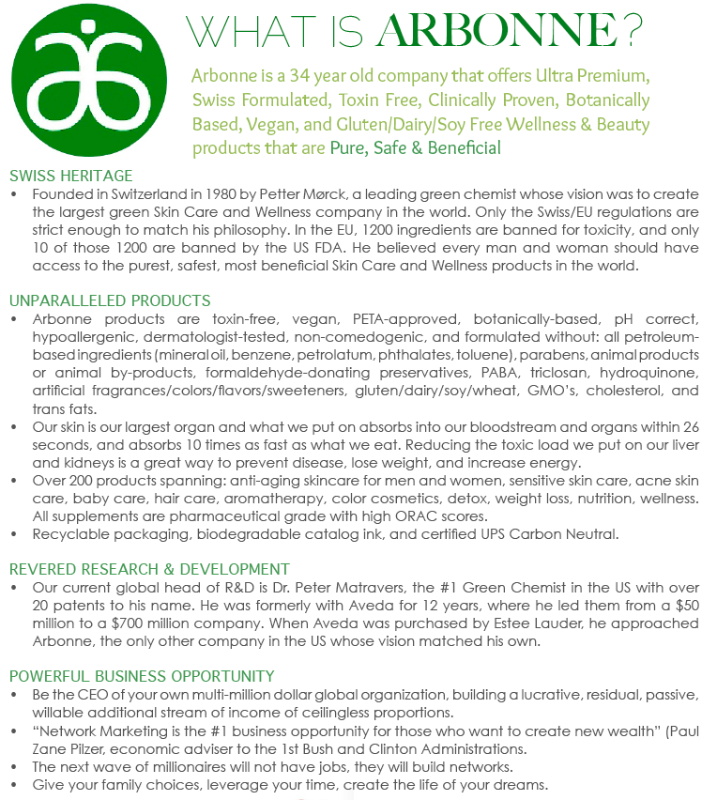

PURE. SAFE. BENEFICIAL.
ARBONNE
A Better Choice… Because These Things Don’t Belong On Your Skin!
What to Avoid in Your Personal Care Products
Many are unaware that modern personal care products also expose us to serious dangers. 99% of all skin care products on today's market contain harmful ingredients, even products that claim to be "organic" and “all-natural.” Daily exposure to ingredients such as preservatives, pesticides, fragrance and dye can cause disease. (Below are just a few. If you want the entire list email me at the email address below and I will be happy to send it to you).
MINERAL OIL/PETROLATUM – Mineral oil is a mixture of refined liquid hydrocarbons derived from petroleum. Mineral Oil is the stabilizing ingredient of many skin formulas. Mineral oil and all petroleum-based ingredients are by-products of crude oil and are ILLEGAL to use in Europe. Petroleum products do not penetrate the skin and are occlusive, blocking natural respiration, excretion/detoxification and absorption of other nutrients. They tend to exacerbate conditions such as eczema, rosacea, dermatitis, etc. Mineral oil is the #1 most used ingredient in American skin care. It costs about $1/gallon, as compared to essential oils which Arbonne uses, which can cost as much as $100/gallon. (Baby Oil is 100% mineral oil!).
PARABENS - preservatives such as parabens (methyl, ethyl, propyl and butylparaben) are used as inhibitors of microbial growth and to extend shelf life of products. Often cause allergic reactions and skin rashes. Parabens mimic estrogen and are linked to breast cancer, lowered sperm count, lowered testosterone levels, testicular atrophy, infertility, increased testicular cancer and undescended testes. Parabens have been found in-tact in breast tumors.
SODIUM LAURYL SULFATE – (and Sodium Laureth Sulfate) - used in car washes, garage floor cleaners and in 90% of products that foam. Animals exposed to SLS and ALS (Ammonium Lauryl Sulfate) experience eye damage, central nervous system depression, labored breathing, diarrhea, severe skin irritation and even death. Often disguised in semi-natural cosmetics with the explanation “comes from coconut.”
PHTHALATES – used in fragrances; Dibutyl Phthalate (DBP). DBP has been classified by several agencies as a reproductive and developmental toxicant, and the European Union banned the use of this ingredient. Prenatal exposure to DBP has been associated with anatomical changes in the reproductive system development in baby boys. In adult men, DBP has been correlated with changes in serum hormone levels, lower sperm concentration and motility, and decreased fertility.
ARBONNE : VEGAN, TOXIN FREE, GLUTEN FREE, NO ANIMAL TESTING, NO ANIMAL BY-PRODUCTS, BONTANICALLY BASED, ORGANIC WHENEVER POSSIBLE. Sources: http://www.cir-safety.org/, www.cancer.org, http://www.hazard.com/msds/, http://www.niehs.nih.gov/health/topics/agents/endocrine/index.cfm,

