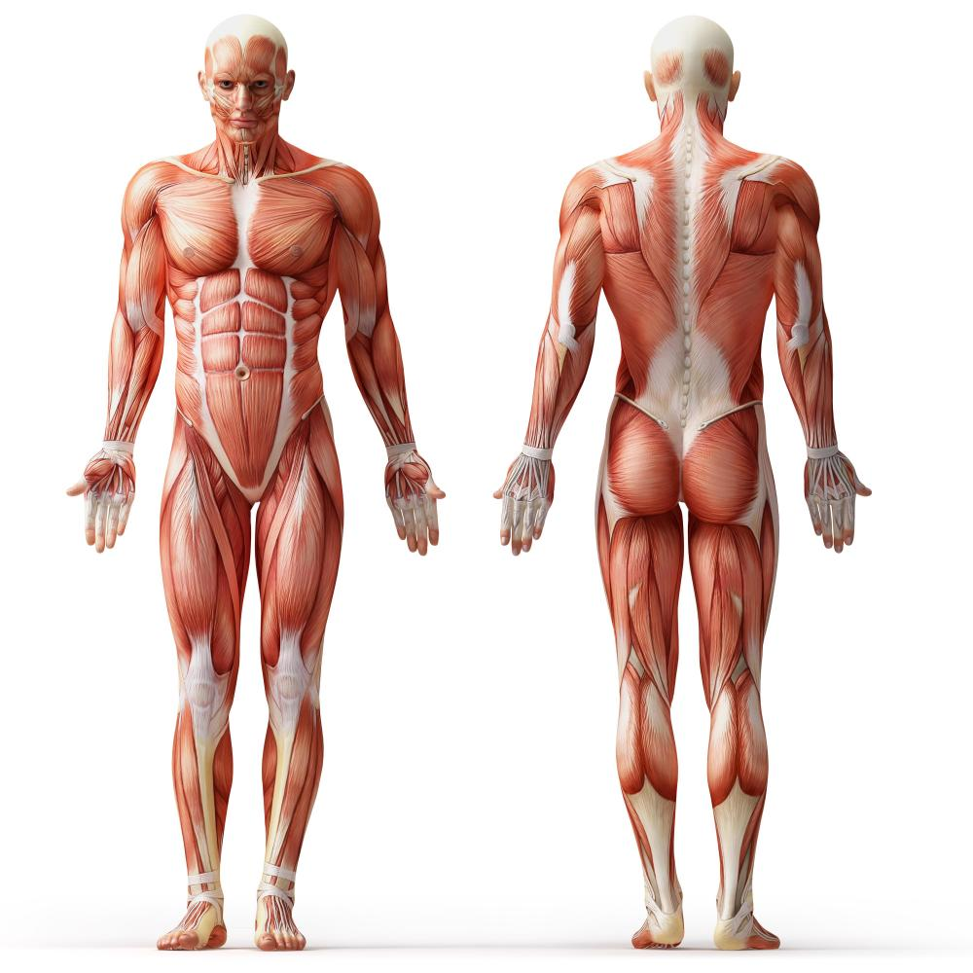

Please circle the areas of the body that are causing you pain.

Name: _________________________________________ Date: _________________________