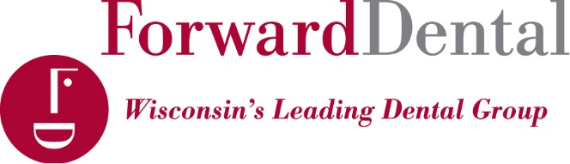

At ForwardDental, we are firm believers that the practice of dentistry must always be based on the doctor-patient partnership.

ForwardDental strives for superior patient satisfaction by delivering a blend of Quality, Convenience, and Caring. We are proud to be among a select few organizations nationwide accredited by the Accreditation Association for Ambulatory Health Care (AAAHC). ForwardDental is proud to provide patient care with a knowledgeable and tenured staff who are required to participate in peer reviews, patient record audits, quality improvement projects, and continuing education, all in accordance with the highest industry standards. ForwardDental embraces the continued technological advances in today’s world through the utilization of digital x-rays, an electronic patient record, intra-oral cameras, and now through digital impression scanning to deliver a comprehensive range of quality services in a comfortable environment.

We believe great dental care should be easy and affordable. That’s why our offices offer early morning, evening, and weekend hours to fit the busy schedules of our patients and we are a preferred provider of most insurance plans. In addition to this, we offer multiple payment options, financing, and a Discount Dental Plan offering discounts for those without insurance.

At ForwardDental, we strive to become a part of the communities we serve through sponsoring the Marquette and Wisconsin athletic teams, participating in Al’s Run, volunteering our services at a free dental clinic, or participating in local community events. We are ardent supporters of dental education by funding endowments for Children’s Hospital and Marquette University (Orthodontics, General Practice Residency Program, Periodontal Program, Endodontic Residency Program, and dental school scholarship).

ForwardDental in Franklin, which includes Drs. Hana Alberti, Anthony Coletta, and Timothy Morschauser and their teams, provide care to patients within the Franklin and surrounding communities.

Dr. Hana Alberti and her team believe in delivering a quality and positive experience for the entire family. She combines current technology with patient empathy to provide comfortable dental care for her patients. She has always been interested in the health sciences, and her desire to work closely with her patients led to her love of dentistry. She completed her undergraduate degree in Microbiology and Immunology at the University of Wisconsin – Madison. Dr. Alberti then went on to the Marquette University School of Dentistry where she earned her Doctorate of Dental Surgery degree in May of 2005. She now serves as a mentor for Marquette dental students and new dentists.

Dr. Anthony Coletta strives to provide quality health care in a compassionate, caring manner. His favorite aspect of dentistry is watching the smiles on his patients' faces when they leave the office. Dr. Coletta is a graduate of the University of Hawaii and Loyola School of Dentistry. His professional affiliations include membership in the American Dental Association, AGD, the American Academy of Cosmetic Dentistry, Academy of Computerized Dentistry of North America, International Academy of Comprehensive Aesthetics.

Dr. Tim Morschauser is a 2015 magna cum laude graduate of the Marquette University School of Dentistry in Milwaukee, WI. Dr. Morschauser’s strive to serve patients began at a young age when his childhood dentist repaired his broken front teeth. It was this experience that left Dr. Morschauser with a desire to pursue a career in Dentistry. He attended UW-Eau Claire and received his Bachelor’s Degree double majoring in Biochemistry and Molecular Biology. He then proceeded to attend The University of Wisconsin-Madison, where he received a Master’s Degree in Endocrinology and Physiology. Dr. Morschauser loves seeing patients every day and spending quality one-on-one time with them. This allows Dr. Morschauser to deliver individualized care to each patient he sees. Dr. Morschauser is a member of the American Dental Association, Wisconsin Dental Association, and Greater Milwaukee area Dental Association.

