Minnesota Farm Bureau Foundation

Paul Stark Memorial Scholarship Guidelines

Who is eligible?

- Any person who is a Farm Bureau member or qualifies as a member under their family's membership.
- Must be enrolled in an accredited school and is going into their freshman or sophomore year of college or vocational technical institute.
- Major must be in agriculture, conservation or forestry related field.

How much is the scholarship? Two $500 scholarships will be awarded.

How they are awarded:
- Based on scholarship, leadership and agricultural interest.
- Creative essay, limited to no more than 500 words, describing the applicant's interest in agriculture, conservation or forestry related field.
- Scholarships will be awarded following receipt of their school year end transcripts. (Freshman or sophomore year in which they received the award. Recipients must maintain a 2.5 GPA or greater. Once transcript is received, funds will be sent to recipient.)

Applications are due September 30. Applications are enclosed.

For more information on the Minnesota Farm Bureau Foundation and the Paul Stark Memorial Scholarship, visit www.fbmn.org.
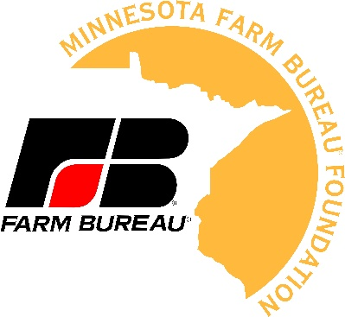

Mail to: Minnesota Farm Bureau Foundation
Attn: Paul Stark Memorial Scholarship
PO Box 64370
St. Paul, MN 55164

Scholarship Recipients will be recognized at the
MFBF Annual Meeting in November.

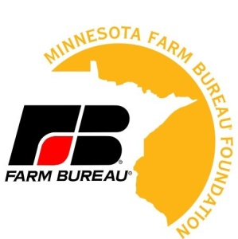

Minnesota Farm Bureau Foundation
Paul Stark Memorial Scholarship Application

Name:

School Address: City: State: Zip:
Home Address: City: State: Zip:
Email: Home Phone: School Phone:

County you are a Farm Bureau member in: Membership #:

Parents Name:

School you are attending: Major:

Describe your involvement with Farm Bureau, 4-H, FFA, FCCLA, community, church or other organizations.
(Please list and describe each below, attach additional sheets if needed):

How do you plan to finance your education? (Please explain below.)

Include the following in your scholarship package:
(Application must be received by September 30 at the address listed below.)

- Creative essay (up to 500 words) describing your interest in an agriculturally related field.

- Wallet size glossy photograph of the applicant.

- Three (3) letters of reference.

- Personal letter from a Farm Bureau member.

- Scholastic letter.

- Employment or organization letter.

Mail all material prior to September 30 deadline to:

Minnesota Farm Bureau Foundation
Attn: Paul Stark Memorial Scholarship
PO Box 64370
St. Paul, MN 55164-0370

Any questions regarding this program should be directed to the MFBF state office at
651-768-2115. This application is also available online at www.fbmn.org under Foundation.

