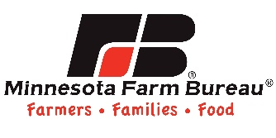
Bulletin Board Contest

Create your BEST bulletin board that teaches students about an agricultural topic and enter to win educational resources! Make sure there are no students in your picture. You may enter more than one bulletin board. Judges will score based on creativity and educational content. Submit November 1, 2016 – April 30, 2017.

First Name: ___________________ Last Name: ___________________
Email: _________________________________________________________
Phone Number: _____ - _____ - ________
School: ________________________________________________________
Address: _______________________________________________________
City: ______________________________ State: _____ Zip Code: _________

Description of bulletin board:

I agree to let Minnesota Farm Bureau Federation (MFBF) use my picture on social media, online and in printed materials.

Photo of bulletin board enclosed.

Email application and photo to: ruth.meirick@fbmn.org

Questions? Contact Ruth Meirick, Director, Minnesota Farm Bureau
651-768-2115

