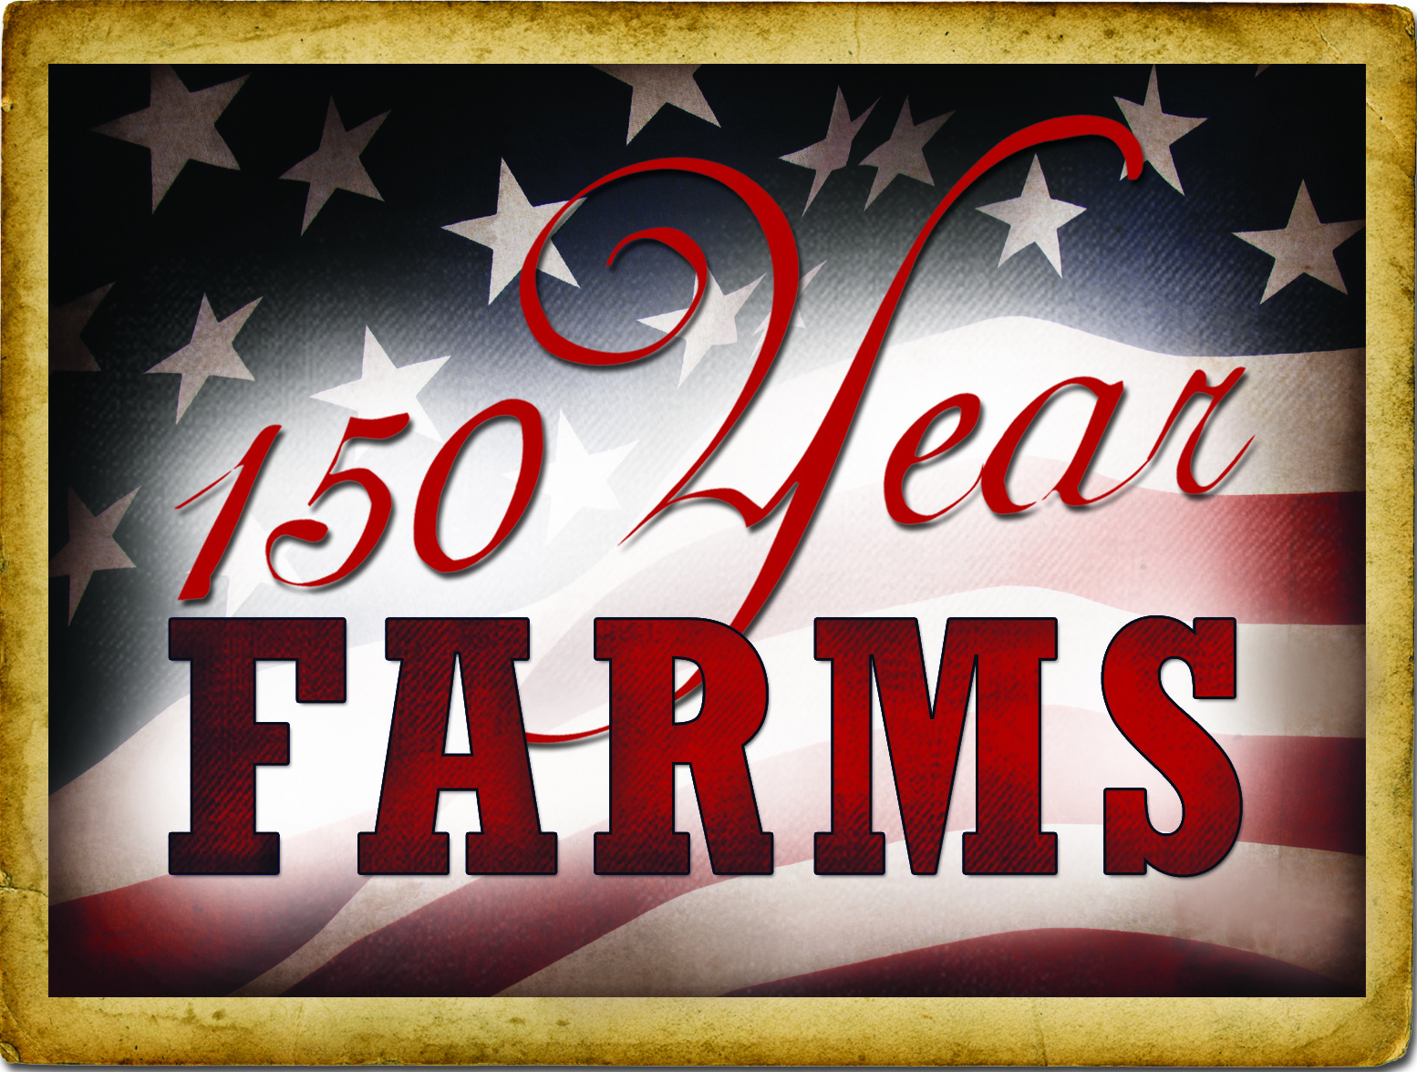
Deadline: April 3, 2017
MINNESOTA FARM BUREAU

SESQUICENTENNIAL FARM APPLICATION – 2016

PLEASE TYPE OR PRINT CLEARLY

PRESENT OWNER OF FARM_______________________________________________________________

NAME TO APPEAR ON CERTIFICATE________________________________________________________

ADDRESS_______________________________________________________________________________
(street) (city) (state) (zip)

PHONE NUMBER area code (____)___________________________________________________________

ADDRESS OF FARM IF DIFFERENT FROM ABOVE_____________________________________________

SECTION___________________ TOWNSHIP_____________________COUNTY_____________________

NUMBER OF ACRES IN THE FARM AT PRESENT__________

DATE OF ORIGINAL PURCHASE BY A MEMBER OF YOUR FAMILY___________________

HAS FARM BEEN PREVIOUSLY REGISTERED AS A CENTURY FARM?__________ IF SO, WHEN______

LEGAL DESCRIPTION OF LAND (from deed, abstract, tax statement, etc)_____________________________

________________________________________________________________________________________

PROOF OF 150 YEARS OWNERSHIP
NAME | YEARS OF OWNERSHIP  FROM - TO | RELATIONSHIP TO NEXT OWNER
First owner

Next owner

Next owner

Next owner

Next owner

The above evidence of continuous family ownership is taken from one or more of the following records.
Check those that apply: Please do not send originals or copies of records.
( ) Abstract of Title ( ) Land Patent ( ) Court File in Registration Proceedings
( ) Original Deed ( ) County Land Record ( ) Other_____________________

I hereby certify that the information listed above is correct to the best of my knowledge and belief.

_______________________________________ _________________________________
(signature of present owner) (date)

ADDITIONAL INFORMATION

Any information you can add to this form will be most valuable to future historians. The questions below are only a guide. Feel free to add other data, especially family or pioneer stories concerning the farm and the area around it. This is not a requirement for Sesquicentennial Farm certification.

From whom was the farm purchased___________________________________________________________

How many acres were in the original parcel_____________________________________________________

What was the cost of the land per acre_________________________________________________________

Where was the first family owner born__________________________________________________________

Did he/she engage in any trades or occupations other than farming___________________________________

If so, please list___________________________________________________________________________

Was this a homestead_____________________________________________________________________

Is the original home, any portion of it, or any other original buildings still standing _______________________

When was the present home built_____________________________________________________________

What were the farm’s major crops or products___________________________________________________

Additional comments:_______________________________________________________________________

________________________________________________________________________________________

________________________________________________________________________________________

________________________________________________________________________________________

________________________________________________________________________________________

________________________________________________________________________________________

________________________________________________________________________________________

________________________________________________________________________________________

________________________________________________________________________________________

________________________________________________________________________________________

________________________________________________________________________________________

________________________________________________________________________________________

Mail application to:
Minnesota Farm Bureau Federation
Sesquicentennial Farms
PO Box 64370
St Paul, MN 55164

