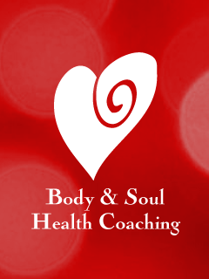
Want a Taste of Health Coaching?
Download my Free Smartphone App!
It’s called …
Baby Steps to a Healthier You at Google Play for Android Phones & Baby Steps to a Healthier, Happier You at the App Store for iPhones
You'll receive a tip daily for thirty days, each designed to move you closer to your Healthier, Happier Life!
See you there … xo Donnalyn
www.DonnalynMurphy.com

